PYTHON EMBLEM

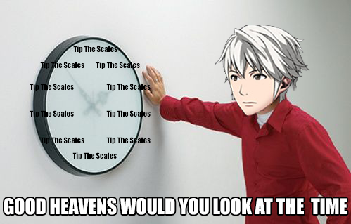USER'S GUIDE

CREATED BY:

DYLAN CONROY

RYAN EGAN

AND WILLIAM ROBERTS

CS110

SECTIONS A51, A52, AND A53

HARIS RIBIC

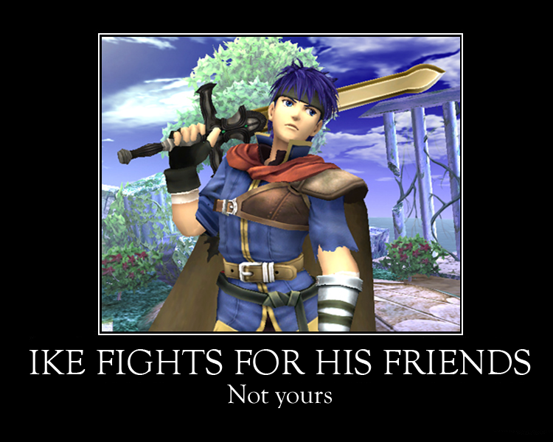

* Welcome to the user guide!
* This guide will provide a step by step explanation to how to play this game.
* This is a game about strategy and using your cunning wits to achieve victory!
* This is a two player game, so grab a friend and duel! If you have no one around to play with, challenge yourself in a game of self deception!

STARTING THE GAME

* Upon starting the game, you will be greeted with a small window like this:

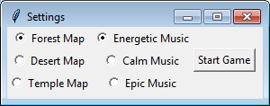

* You can choose what map background image you want during the game, as well as what music you want to play in the background of the game.

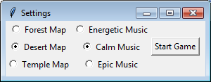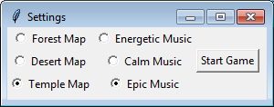

* The map background is only there to look pretty, it does not affect game play!
* When you are done selecting your choices, click "Start Game."

PLAYING THE GAME

* This is a view of the main game screen when it starts out:

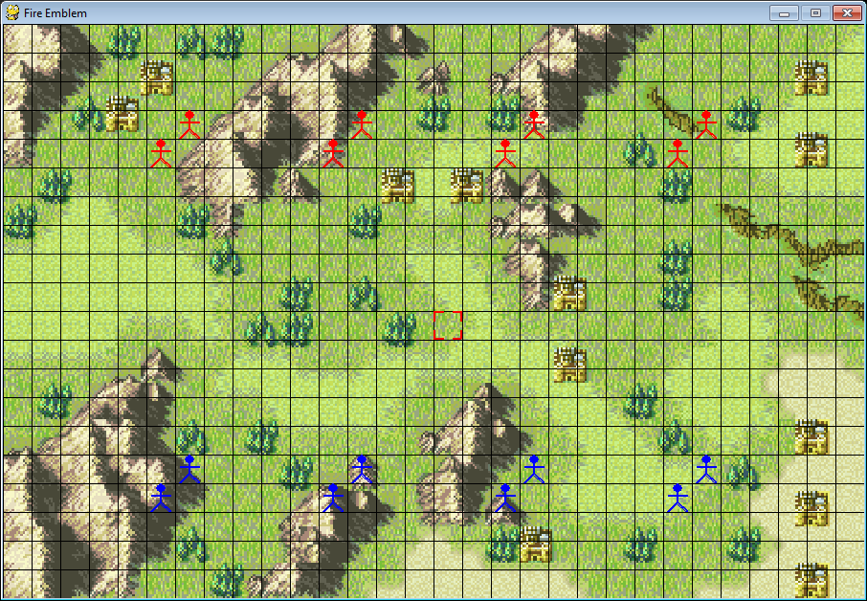

* The game is played on a grid, and you move your units around and attempt to defeat enemy units to win!
* Player 1 controls the Blue units, while Player 2 controls the Red units.
* The game starts with both teams having their units start on opposite sides of the playing field. Player 1 goes first.
* 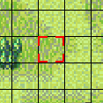This is the cursor. You move it around the map to select units. you control it using the 'W', 'A', 'S', and 'D' keys on your keyboard.
* This will show you what happens when you press the keys:

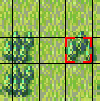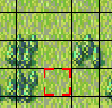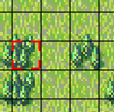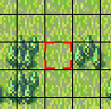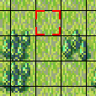

S

A

D

W

* From here, you can select and use units(if it's your turn)
* Move the cursor over one of your units and press the spacebar to select it:
* 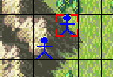You can also select the other player's unit to check their stats and strategize your next move!

THE CHARACTER WINDOW

* When you select a unit using spacebar, a window like this will open:

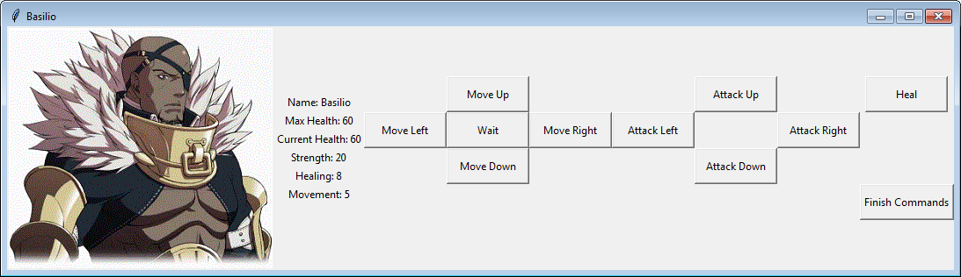

Attack Options

Movement Options

Other Options

Character Stats

Character Portrait

* These are your character's statistics, which affect how they play and interact with other units:

Name: Your Character's name

Max Health: The maximum possible health your character can have.

Current Health: The current value of your character's health. If this becomes zero, then the character is defeated and removed from the game.

Strength: The amount of damage this character can do to enemy units.

Healing: The amount of health a character can regain when choosing to heal.

Movement: The amount of spaces a character can move before ending their turn.

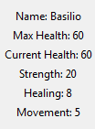

* These are your movement options, which allow you to move your character around the game grid:

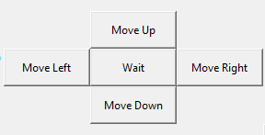

Move Up: Move your character 1 space upwards on the grid.

Move Left: Move your character 1 space left.

Move Right: Move your character 1 space to the right.

Move Down: Move your character 1 space downwards.

Wait: Keeps your character in its current position and ends your turn.

* Upon clicking the buttons, the character moves in such a way:

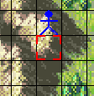

Move Up

Move Left

Move Right

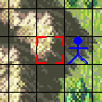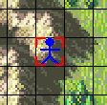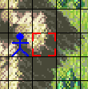

This box appears when you run out of movement options.

Wait

(or do nothing)

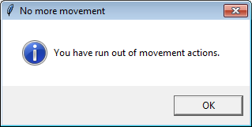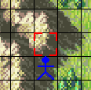

Exit the window by pressing 'OK.'

Move Down

* Attacking causes damage based on your character's strength stat to an enemy unit's health. Sets your movement to zero and exits the window if a successful attack occurs, but does nothing if there is no enemy unit next to your character, and exits the window if the character movement is already zero.

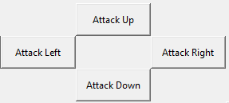

Attack Up: Attacks the enemy adjacent upwards.

Attack Left: Attacks the enemy adjacent to the left.

Attack Down: Attacks the enemy adjacent downwards.

Attack Right: Attacks the enemy adjacent to the right.

Choose direction to attack

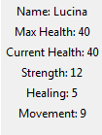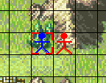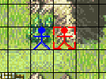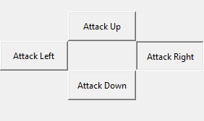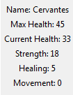

Check enemy status

Select Unit

Enemy health has dropped

Your strength stat

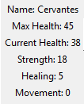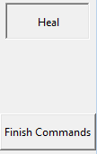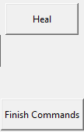

Health has increased

Check status

Click heal

Select Unit

Heal: Increases the current health of your character based on your character's healing stat. Sets your movement to zero and exits the window, but does nothing if the character's health is already maximum, and exits the window if the character's movement is already zero.

Finish Commands: Exits the window. Can be used to check how movement commands have moved the character on screen





* Moving, attacking, and healing, are the basics of combat.
* 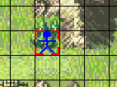When a unit's health drops to zero, they are removed from the game!

Enemy is defeated and removed

Choose direction to attack

Select Unit

TURNS

* Player chooses their commands in their character windows each turn.
* Turns end when every character's movement stat has become zero, or when the player presses Backspace on the keyboard to instantly end their turn. when they are satisfied with their actions.
* Player 1, the Blue Team, takes their turn first, then Player 2, the Red Team, takes their turn.
* A notification will display on screen when the current player's turn ends, telling the other player that it's their turn.

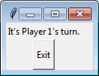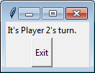

THE TEAMS

* Player 1's team, the Blue Team, is made up of heroes, while the Player 2's team, the Red Team, is made up of villains.
* Choose whether you want to be good or evil, and fight for what's right or what's wrong!
* Each character has a portrait that shows who they are.
* Each character on a team has different stats, so they fit different roles in your team!
* Both teams may have different characters, but both teams have characters with identical stats and starting spaces on the map. It's an equal fight!

WINNING THE GAME

* When one player's team loses all of its units, the other player wins!
* Defeat every character on the other team to win the game.
* 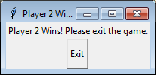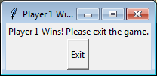When a player wins, a notification will come on screen, depending on who wins the game:
* The game will exit once the "Exit" button is pressed.